Questionnaire - Gothenburg August 20th to 25th 2012
Your name:

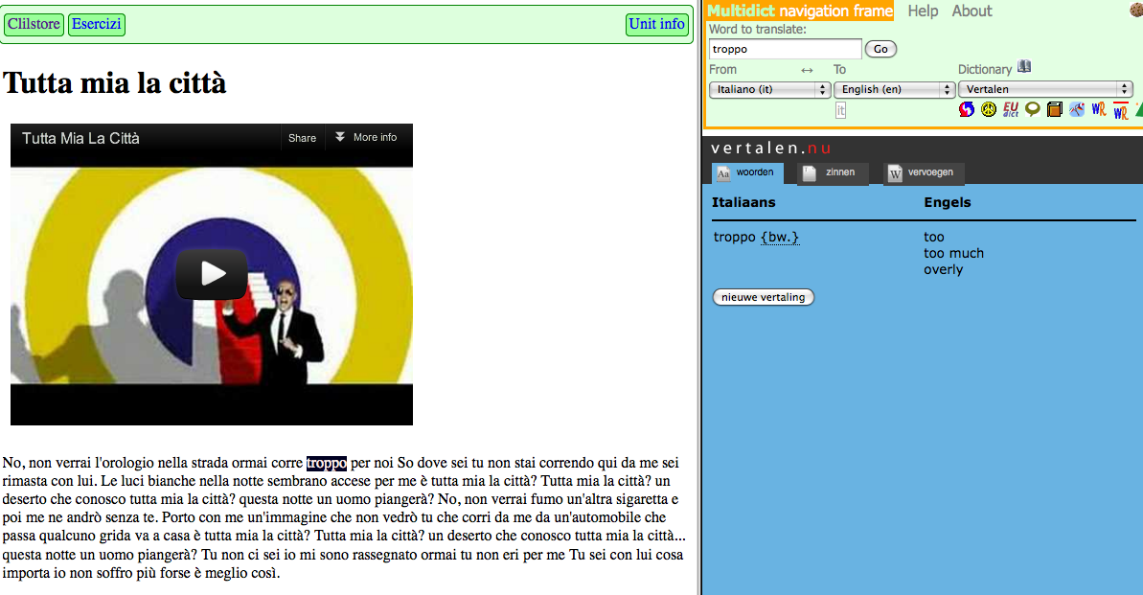

1. The Clilstore interface is currently available in English only, should it automatically (where possible) be available in the language of the browser? Yes/No

2. In the dictionary side of a Clilstore unit there are icons linking to dictionaries in the chosen language combinations in addition to a drop down list. Do you find the icons useful? Yes/No

3. Please name some of your favourite online dictionaries:

4. Should it be possible to create units in Clilstore that can only be accessed by the author and their students (in addition to units which are always available to the general public)? Yes/No

5. Should it be possible to create a personalized menu with selection of Clilstore units, which could have an easy address for the students? Yes/No

6. Should the future entry point to Clilstore be a student-focussed page featuring a login for authors? Yes/No

7. Would you be willing to test future versions of Clilstore? Yes/No
If yes, please supply an e-mail address for our mailing list:

8. More comments? Please write overleaf

